**Christmas is coming…**

**1.) Talk to a partner about Christmas. What do you look forward to most?**

**2.) Watch the video until 03:09 and answer the questions:**

**Which of the following is true?**

o Jay wants Manny to watch an American Christmas classic on TV.

o Jay says it’s a great idea to play practical jokes not only on April Fool’s Day.

o After Gloria and Manny leave, Jay finishes the movie alone.

**Jay wants the family to open one present each in the evening. What is inside?**

o pyjamas to sleep in

o Christmas music to listen to

o candy canes to eat in the evening

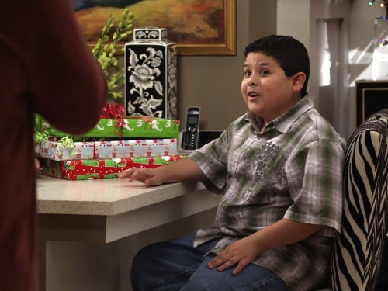

**When do kids open Christmas presents in Colombia, according to Manny?**

o later than American kids

o earlier than American kids

**What does Manny want for Christmas?**

o a turquoise suit and a bow tie

o a brown pair of boots

o a burgundy dinner jacket

**Which Colombian Christmas traditions do Gloria and Manny mention? Take notes**

_______________________________________________________________

______________________________________________________________

_______________________________________________________________

______________________________________________________________

**What do you think will happen next?**

**3.) Watch the rest of the video. Comment on Jay’s reaction to the Colombian traditions.**

**4.) Truth or lie? Tell the class about a Christmas tradition in your family. It can be true or made up! The rest has to guess whether you tell the truth or a lie.**

Link to the video (Modern Family S1E10): <https://www.youtube.com/watch?v=xmYnqHSvIvw>